Ghost Photo

Learning Target: Use slow shutter speed and a tripod to create a fake ghost photo.

Success Criteria: Your ghost photo will show a subject that it is transparent against a properly exposed background.

You will need a tripod and a camera with shutter speed control.

You will need to experiment with shutter speeds to get the correct exposure and to create ghosting of your subject.

Shoot your photos in a dimly lit room. Use a slow shutter speed that will properly expose the background. Have your subject pose motionless for part of the exposure, then quickly move out of the frame. You could try adding effects with a flashlight, candle, or other light source.

Bonus Lesson: You could also use Pixlr for this effect. Use a tripod to ensure that the camera doesn’t move between pictures. Take a picture of the background without your subject. Take the same picture again with your subject. In Pixlr, put the subject photo in a layer on top of the background photo and adjust the opacity of the subject photo to create a ghost effect.

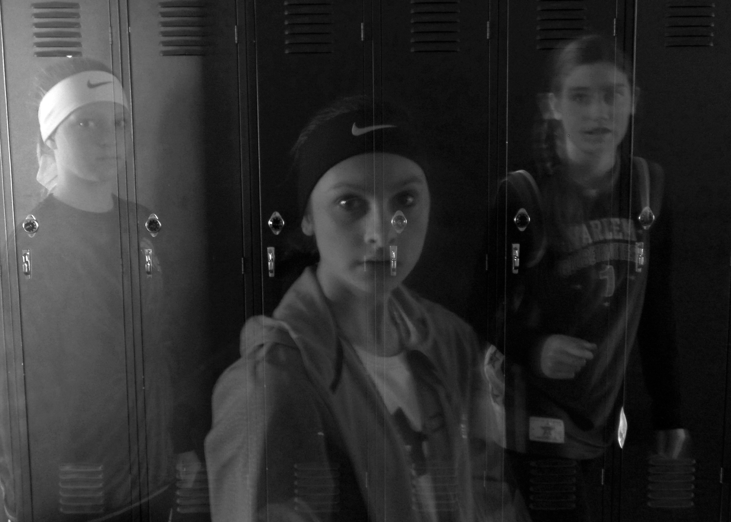
Name _________________________________________________________ Hour ________

Ghost Photo Point Sheet

Turn in your best three ghost photos.

They must be 5x7, .jpg, and named properly.

LastName FirstName AssignmentName - DescriptiveTitle

Simpson Homer Ghost Photo - Ghost of Marge

Ghost Photo 1
10 points for a subject that is ghosted (transparent but still recognizable)
10 points for a background is that properly exposed
10 points for creativity (composition, framing, point-of-view)

Ghost Photo 2
10 points for a subject that is ghosted (transparent but still recognizable)
10 points for a background that is properly exposed
10 points for creativity (composition, framing, point-of-view)

Ghost Photo 3
10 points for a subject that is ghosted (transparent but still recognizable)
10 points for a background that is properly exposed
10 points for creativity (composition, framing, point-of-view)

Due Date:
10 points for turning in all three photos by the due date

