Name ______________________________________________________________ Hour ________

Photo Essay

Learning Target: Use photos and words that support each other to tell a story.

Success Criteria: Create a photojournalism project about your community and publish it as a website.
- Choose your subject. Pick something you care about, know about, and can take pictures of. If you need story ideas, pay attention to conversations around you. Listen for urgency or intensity. Consider people you know.

What are some things, issues, or stories that you care about?

- Develop your story. Every story has a setting, characters, conflict, and resolution.

What is the topic of your story?

Where and when does your story take place?

Who is your story about?

What is the conflict or complication?

How is the conflict resolved?

- Take your pictures. Spend some time with your subject(s) so you get to know each other and so you know more of the story. Try to capture natural, candid moments.

For visual variety, you will need three types of shots: overall, medium, and close-up.

Overall shots set the scene

When you take in a scene, you move your eyes from side to side to survey the entire panorama. The overall photo gives a similar perspective. The overall shot allows the viewer to understand the time and place of the story. It should give a survey of the setting for your story.

Medium shots tell the story

Shoot the picture close enough to see the subject(s) in action, yet far enough away to show their relationship to one another and to the environment. The medium shot contains all of the storytelling elements. The photo must tell the story quickly by compressing the important elements into one image.

An accident photo may show the victims in the foreground and the wrecked car in the background. Without the car, the photo would miss an essential detail – the cause of the victims’ injuries. With only the crumpled car, the reader would wonder if anyone had been hurt. The combination of elements - car plus victims – briefly tells the basic story.

Close-up shots add drama

The close-up puts the viewer into eyeball-to-eyeball contact with the subject. At this intimate distance, a subject’s face connects with the viewer and helps build understanding.

How close is close? The close-up should isolate one element. Not all close-ups including person’s face. Sometimes objects can tell the story. A close-up of a child’s doll covered with mud might tell the story of a flood better than an actual view of the disaster.

Look at the examples of the three types of shots on the next page, then use Google to search for examples of photojournalism and photo essays. Identify the type of shot used in the examples you find: overall, medium, or close-up.

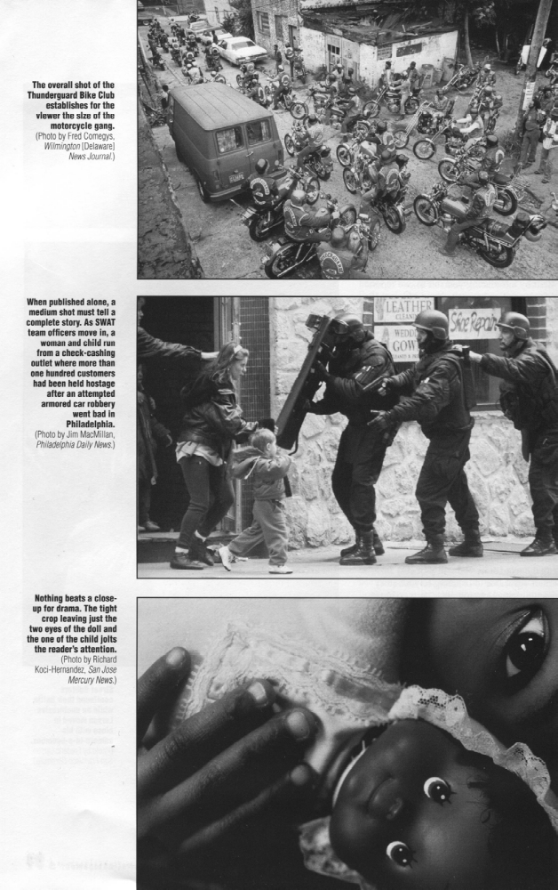

- Choose the right pictures to tell your story.
- Use 5 to 10 photographs.
- Use at least 1 overall shot, 1 medium shot, and 1 close-up shot.
- To tell a story, your photos must work together to set the scene, reveal the character(s), and show the conflict/complication and the resolution.

- Write a caption for each picture.
- Use Google Docs so you can copy and paste the caption into your website.
- Keep it simple.
- Explain what we need to know to put the picture into context.
- Ask me to check for errors so you can correct them before you publish your story.

- Write a headline.
- It should reflect the theme of your photo story.
- It should draw readers in to your story.

What is your headline?

- Publish your photos, captions, and headlines as a website.
- Use Weebly or another website creating app that you are comfortable with.
- Include 5 to 10 photos, a caption for each photo, and a headline.
- You can add an introductory paragraph if you want to.
- Put the address of your completed website in a Google Doc and put a copy of that doc in the Google Drive photography class folder.
- Put copies of your photos in the Google Drive photography class folder.

Name ______________________________________________________________ Hour ________

Your photos must be 5x7, .jpg, and named properly, like this:
LastName FirstName ProjectName - DescriptiveTitle
Simpson Homer Photojournalism – A Leak at the Nuclear Plant

Headline and Introduction

5 points for technique (clear writing with few errors)
5 points for creativity (thoughtful, informative writing)

Photos

20 points for technique (clarity, exposure, presentation)
20 points for creativity (framing, composition, point of view)
20 points for telling a story

Captions

10 points for technique (clear writing with few errors)
10 points for creativity (thoughtful, informative writing that fits each photo)

On Time

10 points for turning in the complete project by the due date:

