Focus Control

This project will teach you to control depth of focus in your camera to create an image with a clear, sharp subject and a soft, out-of-focus background.

To keep your subject/focal point in focus:

- Use a shutter speed of 1/60 or faster. (Or use a tripod.)
- Make sure the camera lens is focused is on your subject or focal point. (The class cameras have a rectangle that turns green to show where/if the lens is focused. Your camera may have a different signal.)

To decrease depth of focus and increase background blur:

- Use a wide-open aperture, like 2.8 or lower.
- Shoot with the subject very close to the lens. (Use macro mode if needed.)
- Increase the distance between the subject and background.

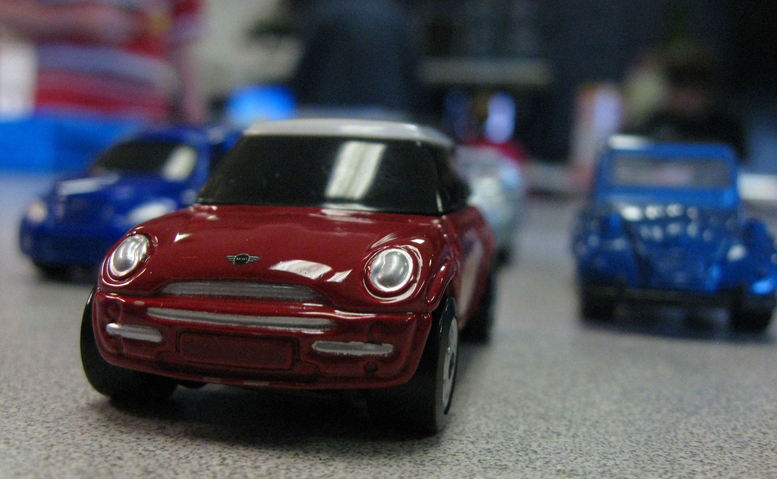

Name ______________________________________________________________ Hour ________

Focus Control

You will be shooting three different subjects: 1) toy cars, 2) small dolls or action figures, and 3) a subject that you choose and bring in. Spend one class period on each subject. Check your images on a larger screen and reshoot to make improvements.

Try focusing on different points on your subject. For example, you might try focusing on the car’s near headlight, then on the windshield, then on the steering wheel. You might need to use the macro setting or manual focus setting on your camera.

Turn in your best photo of each subject, so three photos in total.

Your photos must be .jpg, cropped 5x7 (or 7x5), and named properly, like this:

LastName FirstName AssignmentName - DescriptiveTitle

Simpson Homer Focus Control Cars - Purple Sparkly Dune Buggy
Simpson Homer Focus Control Dolls - G.I. Joe Swings on a Vine
Simpson Homer Focus Control Choice - Red Lego Mobile

LT: Control depth of focus in your camera.
SC: Keep your subject/focal point in sharp focus. Keep your background soft and out of focus.

Cars
10 points for clear, sharp focus on the subject/focal point
10 points for a soft, out of focus background
10 points for creativity (composition/focal point, framing, point-of-view)

Dolls
10 points for clear, sharp focus on the subject/focal point
10 points for a soft, out of focus background
10 points for creativity (composition/focal point, framing, point-of-view)

Choice
10 points for clear, sharp focus on the subject/focal point
10 points for a soft, out of focus background
10 points for creativity (composition/focal point, framing, point-of-view)

On Time
10 points for turning in all three photos by the due date.

