U.F.O. Project
For decades the government, the Masons, and Justin Timberlake have been working together to produce fake UFO pictures to distract us from the real UFOs they have been reverse engineering. Make a few of your own and maybe they will offer you a job.

First: Take a picture of a UFO (or bigfoot or whatever) in front of a plain background.
Second: Use “remove.bg” to remove the background and isolate your UFO image.
Third: In Pixlr or Photopea, open an existing photo of yours and add a layer with your UFO.
Fourth: Adjust the levels and other things to make your UFO look natural in the finished photo.
Fifth: Flatten or merge the layers into a finished image and save it.
Sixth: Keep an eye out for men in black suits and sunglasses.

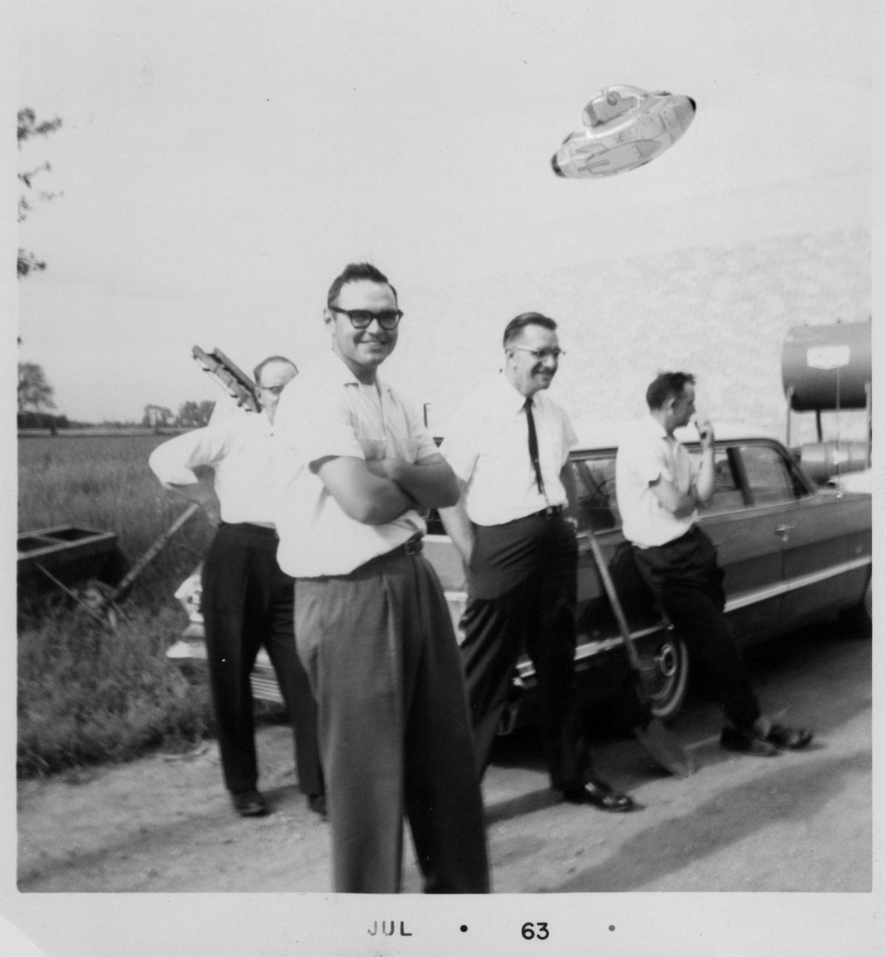

Name _________________________________________________________ Hour ________
U.F.O. Project
Project instructions are on the other side of this sheet.

Turn in your best three photos.
They must be 5 x 7, .jpg, and named properly, like this:
LastName First Name ProjectName - DescriptiveTitle
Simpson Homer UFO – Alien Monkey Flying a UFO

Learning target: Combine two separate images using photo-editing software.
Success Criteria: Take a photo of a U.F.O. (or maybe bigfoot or a dinosaur) and use layers in Pixlr or Photopea to add it to an existing photo.

Photo 1

10 points for using layers to combine two images
10 points for technique (clarity, exposure, presentation)
10 points for creativity (composition, framing, point-of-view)

Photo 2

10 points for using layers to combine two images
10 points for technique (clarity, exposure, presentation)
10 points for creativity (composition, framing, point-of-view)

Photo 3

10 points for using layers to combine two images
10 points for technique (clarity, exposure, presentation)
10 points for creativity (composition, framing, point-of-view)

On Time

10 points for turning in all three photos by the due date

