No Place Like Home
Posted October 15, 2009 at 02:41 PM
https://www.mlive.com/news/grand-rapids/index.ssf/2009/10/hidden_encampment_provides_sup.html (Homeless Camp)

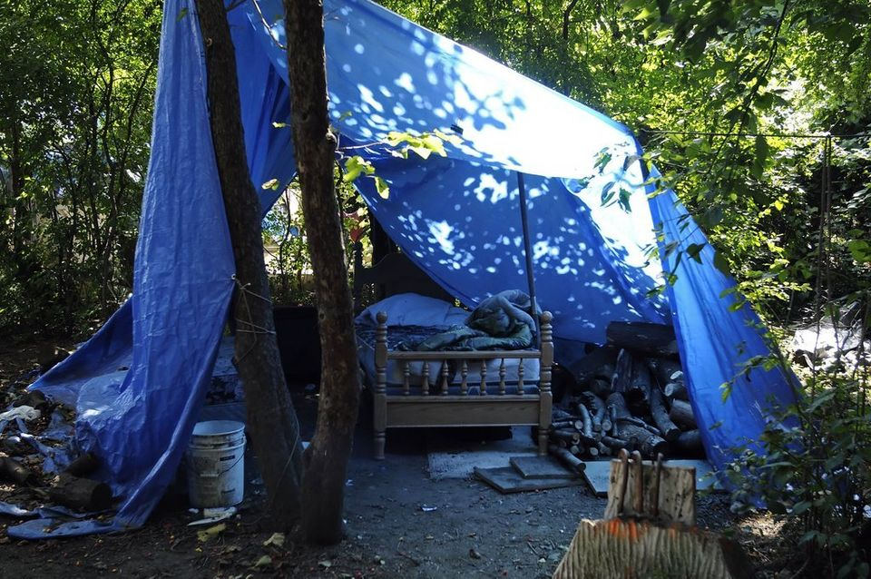
1
Cory Olsen | colsen@mlive.com
This is an area for visitors of the camp to get some sleep. Gilbert Garcia, who has called the camp home for the last three years, said people who are too drunk to go home usually are the ones who sleep there for the night. (Octavian Cantilli | The Grand Rapids Press)

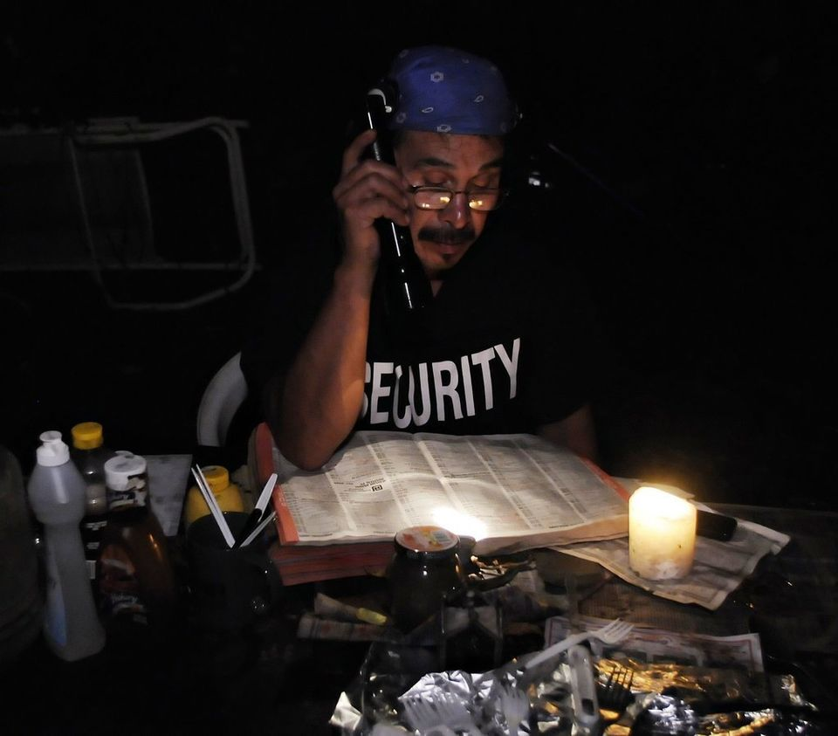
2
Kate Nagengast | knagenga@mlive.com
Gilbert Garcia, 46, looks through a phone book for the numbers to local hospitals and the county jail. His girlfriend, Julie Miller, never returned after leaving to do laundry early the day before. (Octavian Cantilli | The Grand Rapids Press)

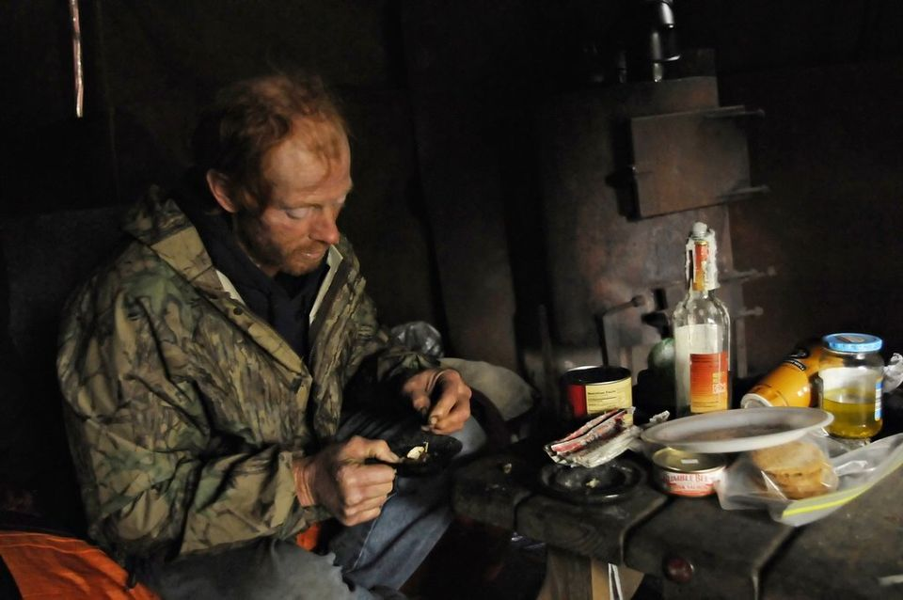
3
Kate Nagengast | knagenga@mlive.com
Dennis, who gave three last names, picks through an ash tray for loose tobacco. He supports himself, including his smoking and alcohol habits, with the money he makes collecting cans and bottles around town. "I'm alive to keep burning," he said. "My equilibrium, that's what my down fall is." Dennis said he's lived at the camp for six years. (Octavian Cantilli | The Grand Rapids Press)

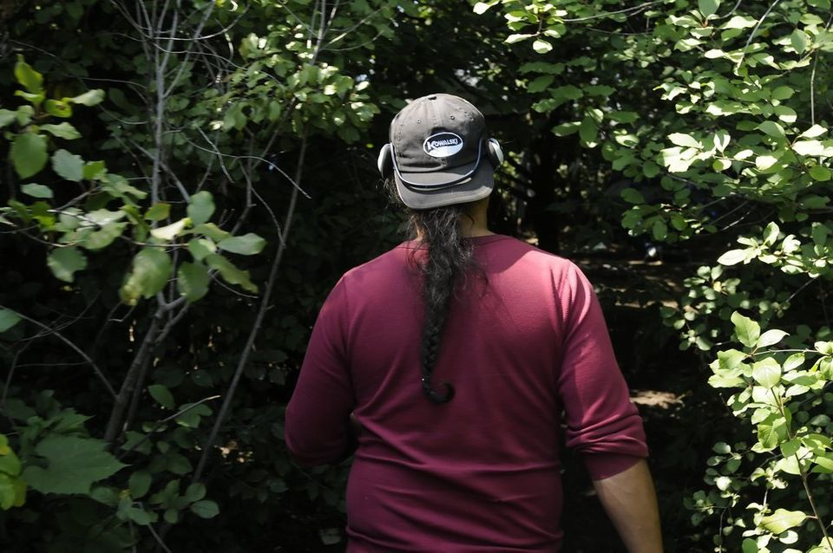
4
Cory Olsen | colsen@mlive.com
Gilbert Garcia, 46, enters through an opening leading to one of the four areas that makes up the homeless camp. (Octavian Cantilli | The Grand Rapids Press)

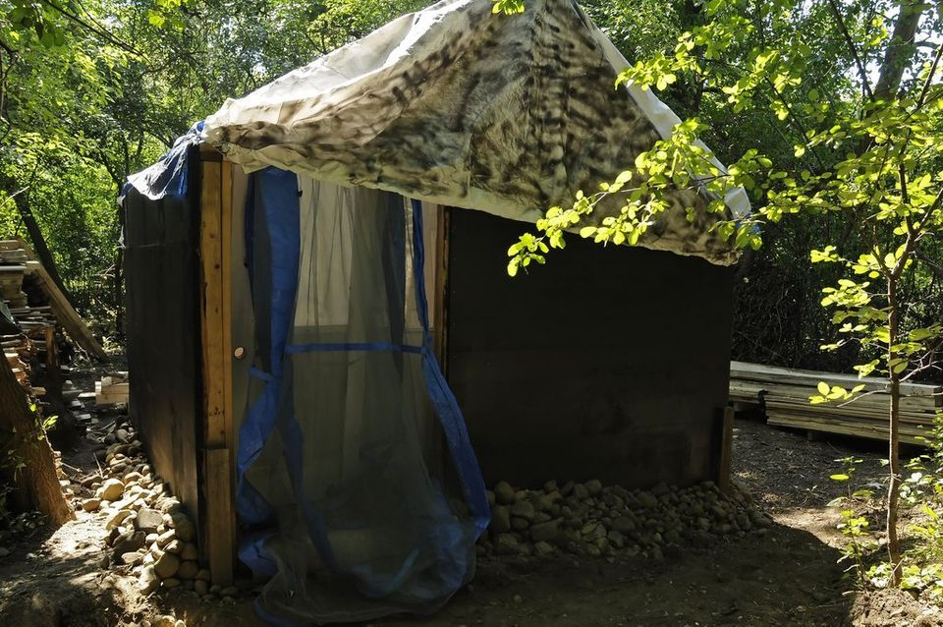
5
Cory Olsen | colsen@mlive.com
Dave has a job, and an apartment, but he said he makes so little that he can no longer afford rent. So he is building this semi permanent structure to live in until he can get back on his feet. He hauls in the scrap material to build the home by bicycle. (Octavian Cantilli | The Grand Rapids Press)

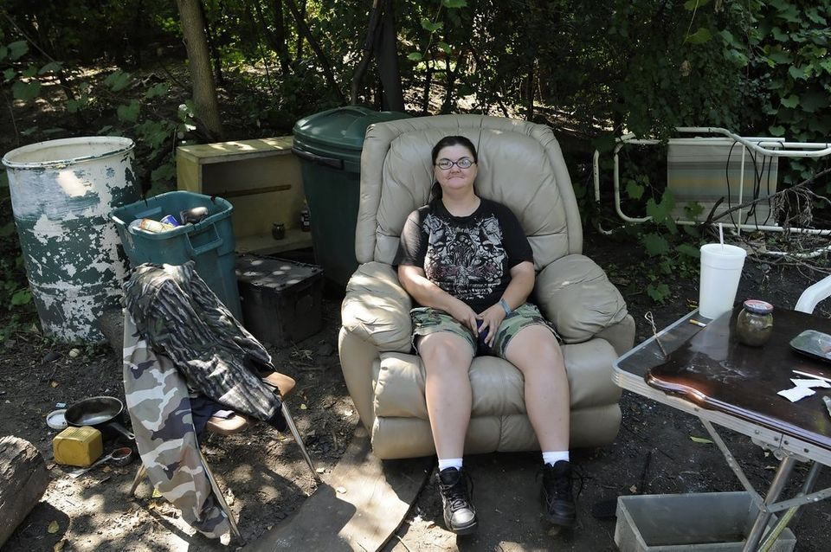
6
Cory Olsen | colsen@mlive.com
Julie sits in her favorite chair at her home of three years. She said the chair was a gift from a friend. (Octavian Cantilli | The Grand Rapids Press)

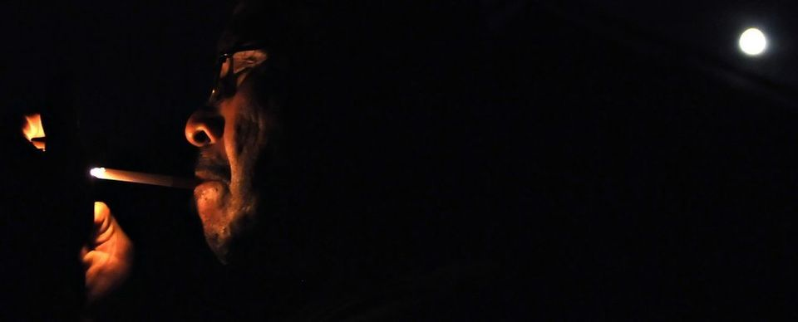
7
Cory Olsen | colsen@mlive.com
Gilbert Garcia lights a hand rolled cigarette at his home of three years. (Octavian Cantilli | The Grand Rapids Press)

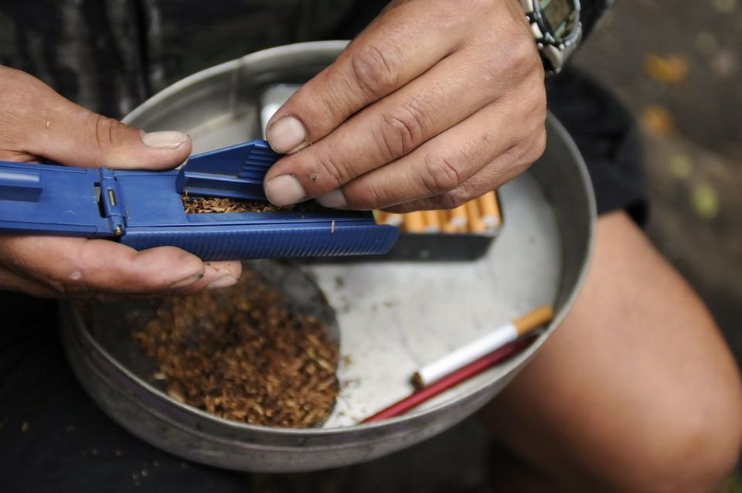
8
Cory Olsen | colsen@mlive.com
Gilbert Garcia, 46, rolls his own cigarettes as a way to save money. (Octavian Cantilli | The Grand Rapids Press)

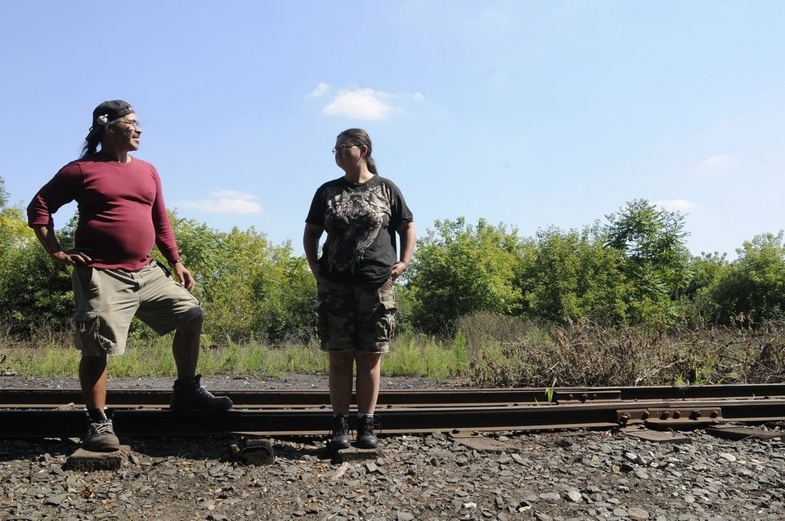
9
Cory Olsen | colsen@mlive.com
Gilbert Garcia, 46, and Julie Miller, 30, have been together for three years while living at the homeless camp. (Octavian Cantilli | The Grand Rapids Press)

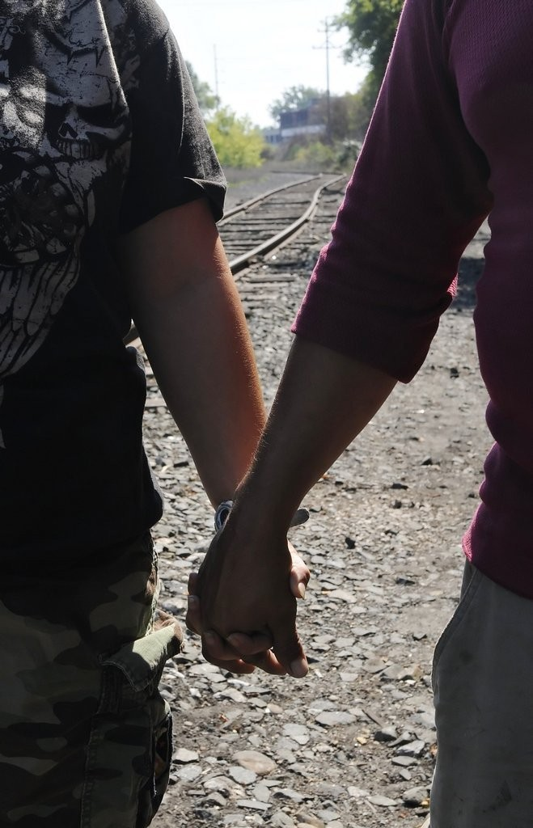
10
Cory Olsen | colsen@mlive.com
Gilbert Garcia, 46, and Julie Miller, 30, have been together for three years while living at the homeless camp. (Octavian Cantilli | The Grand Rapids Press)

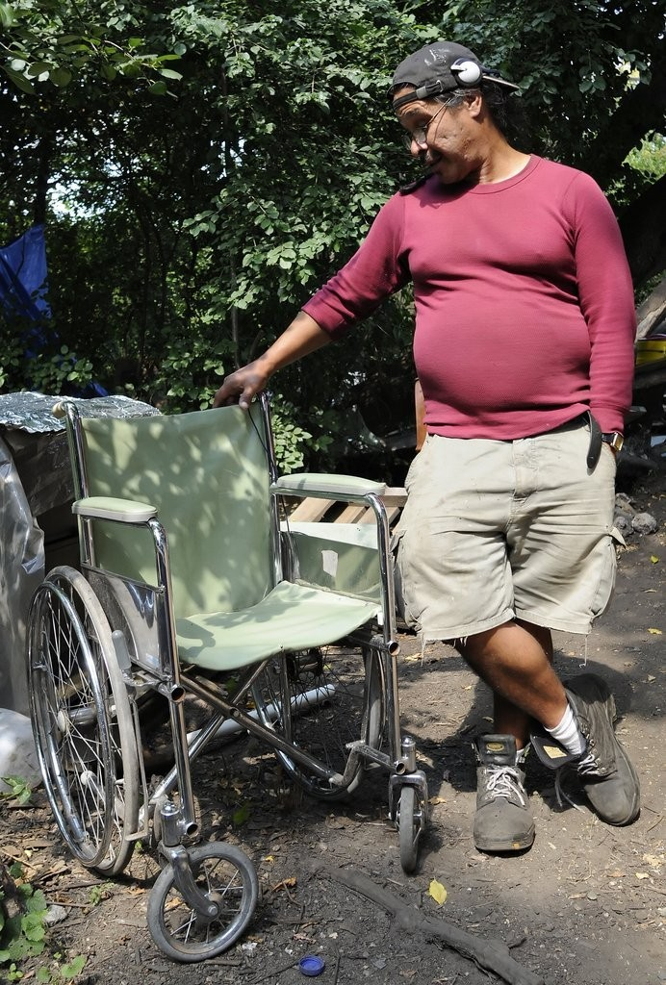
11
Cory Olsen | colsen@mlive.com
Gilbert Garcia, 46, stands next to a wheelchair he found in a hospital's dumpster. (Octavian Cantilli | The Grand Rapids Press)

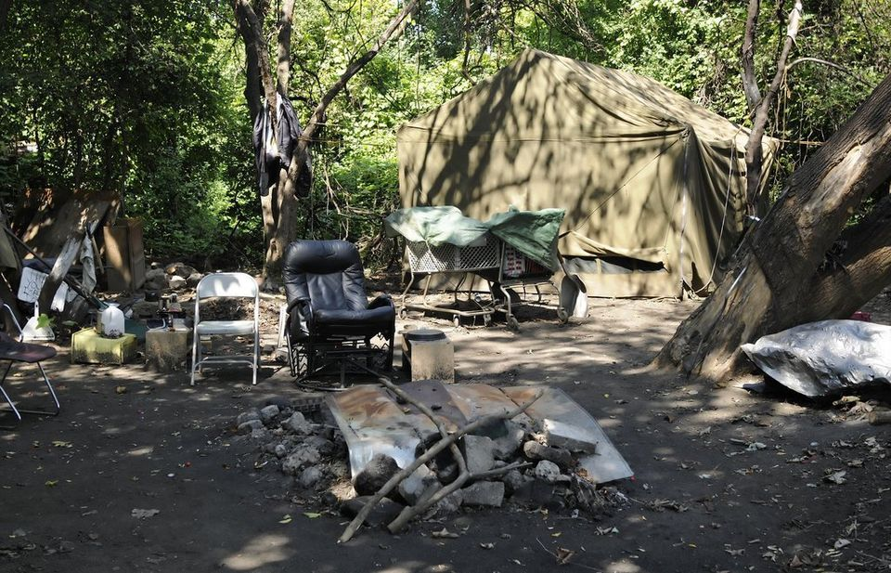
12
Cory Olsen | colsen@mlive.com
This is the largest area within the homeless camp. Dennis, whose tent is on the right, said he has lived there for six years. (Octavian Cantilli | The Grand Rapids Press)

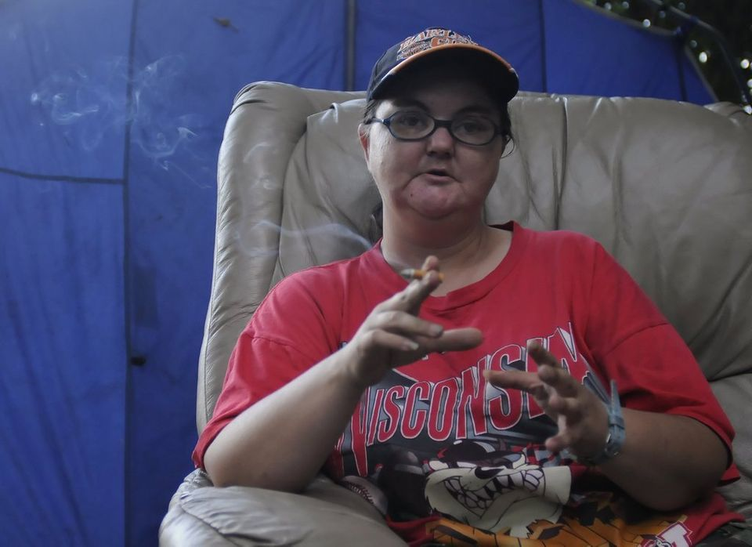
13
Cory Olsen | colsen@mlive.com
Julie Miller, 30, talks about her tough life which includes being abandoned by her mother when she was 16, beaten by men, having children that she can't see, drug abuse, and trouble with the law. (Octavian Cantilli | The Grand Rapids Press)

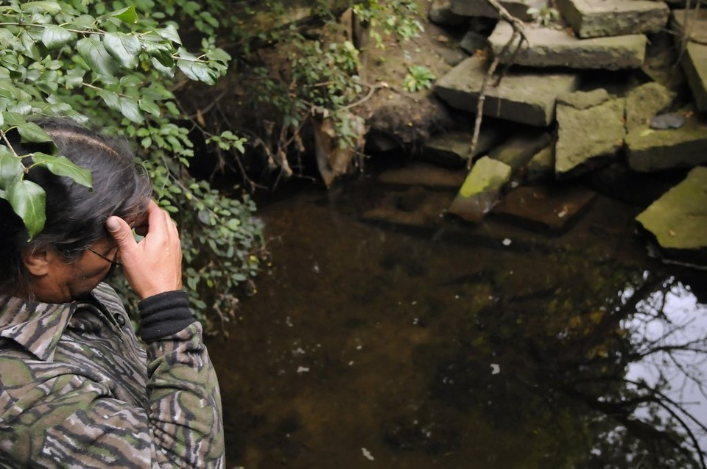

14
Cory Olsen | colsen@mlive.com
This is a storm drainage area next to an industrial park where Gilbert Garcia, 46, said camp residents used to wash their clothes, until they noticed their clothes wearing away faster. (Octavian Cantilli | The Grand Rapids Press)

