Name ___________________________________________________ Hour ________

LA 8 (4-19)

“Get your facts first, and then you can distort them as much as you please."

-Mark Twain

Quick-Write: What do you think about the quote?

Argumentative Essays

“Middle school students shouldn’t play violent video games.” “Jaws is the greatest horror movie ever.” “Horror stories are good because they help readers escape their fears.”

You might have opinions like these. Of course, not everyone will agree with your point of view, but you can try to convince them that your point of view is correct by presenting evidence and arguments to support your point of view.

In this unit, you will be asked to write an argumentative essay to share your point of view on an issue that you care about. It could be about the role that horror or suspense plays in your life or in society, or it could be about any issue that affects you. Your goal is to convince others to share your point of view by presenting arguments and evidence. To do this, you should state a clear opinion, which is your thesis or claim, and then back it up with strong reasons and arguments supported by logical reasoning and relevant evidence.

Warm-Up: For or Against?

Look at the list of issues in the first column of the chart below. Identify your opinion about each issue by placing a check mark in the appropriate box.

Issue | I support it. | I don’t support it.
Require students to do volunteer service.
Ban cell phone use in the hall between classes.
Serve only vegetarian meals in the cafeteria.

Now choose one of the three issues. Which one do you feel strongly about? Meet with others who also chose your issue and compare your position and reasons to theirs.

Next, on the following page, write a convincing letter that explains the problem, your position on it, and your reasons why. Write for five minutes.

Start like this:

Dear _______________________________,

I think we should/shouldn’t _________________________________________________
because...

Reading Sample Argumentative Essays
In these two argumentative essays from “Violence in the Movies: Cinematic Craft or Hollywood Gone Too Far?” in Studysync, the writers explains why violence in movies is (or isn’t) a problem. The side notes explain the main parts of the first essay.

Essay #1
Hollywood, Stop Exposing Our Kids to Violence!
Violence in Hollywood movies has become excessive and is putting our youth and our entire society at risk for violent behaviors. In the golden age of Hollywood, filmmakers relied on solid storytelling techniques to entertain audiences. Unfortunately, today’s film industry often draws audiences to movie theaters with promotional promises of action-packed violence, brutal murders, and mass destruction.
The beginning introduces the problem and clearly states an opinion (which is the thesis or claim).
Violence in movies is on the rise. Researchers at the Annenberg Public Policy Center (APPC) of the University of Pennsylvania found that “the amount of gun violence shown in PG-13 films has more than tripled since 1985.” Children are being exposed to high levels of violence in movies, television, and other media throughout the span of childhood. According to research published by the American Academy of Child and Adolescent Psychiatry, “The typical American child will view more than 200,000 acts of violence, including more than 16,000 murders, before age 18.”
The middle paragraphs present reasons that support the opinion.

Each paragraph discusses one reason.

Each reason is supported by relevant evidence and logical reasoning.
Researchers have found tremendous evidence that links exposure to violence in media and violent behavior in children. In 2000, researchers from six leading medical organizations, including the American Medical Association and the American Psychiatric Association, identified a connection. They reviewed hundreds of scholarly studies on media violence and its influence on aggressive behavior in children. They reported their conclusions to Congress, stating that “viewing entertainment violence can lead to increases in aggressive attitudes, values, and behavior, particularly in children.”
Another 2005 review of such studies, published by The Lancet and reported by the New York Times, concurred. It found that “exposure to media violence leads to aggression, desensitization toward violence and lack of sympathy for victims of violence, particularly in children.” How can anyone deny the existence of a link between media violence and violent behavior in children when it is being proven and supported by our country’s top researchers? “The evidence is overwhelming,'' stated Jeffrey McIntyre of the American Psychological Association. ''To argue against it is like arguing against gravity.”
What Hollywood filmmakers must understand is that children mimic what they see in movies. When a hero exhibits violent behaviors to defeat an enemy, children follow his lead. They learn that violence is an acceptable form of problem solving. Those who see themselves as victims may be more likely to act out in violent behaviors. They may act against peers, parents, teachers, or other authority figures. According to the U.S. Bureau of Justice Statistics, in 2011, students ages 12-18 were victims of 597,500 violent victimizations at school.
“Violence in the media has been increasing and reaching proportions that are dangerous,” Emanuel Tanay, MD, reported to Psychiatric Times. The former Wayne State University professor and forensic psychiatrist argues “What we call entertainment is really propaganda for violence. If you manufacture guns, you don’t need to advertise, because it is done by our entertainment industry.” Do we really want to teach our children that guns and violence are the answers to our problems?
Some people do not believe that exposure to violence in movies is a risk factor for violent behavior. This is because they themselves have not been affected by the exposure. However, no one would reasonably argue, “I’ve always ridden my bicycle without a helmet, and I have never incurred a head injury. Therefore, there is no link between not wearing a bicycle helmet and increasing your risk of getting a head injury.” Why apply such flawed reasoning when it comes to violence in Hollywood movies?
Here the author addresses a couple counterarguments.

This is still the middle part of the essay.
Others suggest that it is up to parents to protect their children from violence in films. They urge parents to follow the rating guidelines set by the Motion Picture Association of America (MPAA). However, APPC researchers report that PG-13 movies portray the same amount of violence as R-rated movies. Parents can no longer rely on MPAA’s film ratings to help determine which movies are suitable for children.
Of course, media violence is not the only risk factor for violent behavior in children. Still, it is certainly a large threat. Screenwriters and moviemakers do not need to resort to depictions of sensational violence. There’s no need to put children and the society at large at risk in order to entertain audiences. Good storytelling creates suspense. It keeps an audience engaged with the suggestion that something terrible is about to happen. Playwrights of Ancient Greece included violent elements such as murder and suicide in their stories, but these violent actions happened offstage, and audiences remained emotionally engaged just the same. Movies should present scenarios in which conflict is resolved through nonviolent behaviors, without weapons. It’s time to hold filmmakers accountable for the violent messages they are sending out to society and to our children.
The ending supports the writer’s arguments and reminds us why the writer’s opinion matters.

Essay #2
Hollywood Filmmakers Should Not Be Villainized for Movie Violence
Hollywood filmmakers include violence in movies as part of the craft of storytelling, to create an enjoyable movie-going experience for the audience. It is not right to restrict their abilities to tell stories through film. It is also inappropriate to limit entertainment options for people who enjoy watching action and horror movies but have no tendency toward violence themselves.
Some people feel that violence in media causes people to act violently in real life. This just isn’t true. I watch violent movies on a regular basis, and I have never engaged in violent behavior. I’m not the only one, either. Millions of Americans see violent imagery in films and on TV every day, but very few commit violent crimes.
Violent behavior is an extremely complex issue that cannot be reduced to a simple cause-effect relationship. The Center for Disease Control and Prevention (CDC) has identified many risk factors for youth violence. These include history of early aggressive behavior, exposure to violence in the family, low parental involvement, association with delinquent peers, low IQ, poor academic performance, low socioeconomic status, and many others. Exposure to violence in movies does not appear on the CDC’s list.
Although some psychological studies seem to prove a connection between media violence and violent behavior, those links are not significant enough to justify restrictions on movies. Jonathan L. Freedman, a professor of psychology at the University of Toronto, reported “a very small correlation” between media violence and aggressive behavior in children. Freedman suggested that violent behavior is most likely present in children who lack regular adult supervision. How can we hold filmmakers responsible for putting children at risk when it’s a parental duty to monitor what children are watching? Parents must teach their children appropriate behaviors. They must help their children interpret the violence they encounter in movies as fantasy, not reality.
Opponents of movie violence claim that crime is on the rise. According to the U.S. Bureau of Justice Statistics, crime rates have dropped steadily since 1993, when 80 of every 1,000 people reported being victims of violent crime. The homicide rate declined 48% from 1993 to 2011. In fact, violent movies may actually play a part in this reduction in violent crime. Children who are watching a movie are taking part in a nonviolent activity. Movie watching provides time for entertainment. It takes away from the time in which these children might engage in violent behaviors. According to Gordon Dahl and Stefano DellaVigna, research associates of the National Bureau of Economic Research, “estimates suggest that in the short-run violent movies deter almost 1,000 assaults on an average weekend.” Because watching violent movies provides those who might otherwise engage in violent behaviors with an alternative, nonviolent activity, it turns out to be a beneficial activity to those with aggressive tendencies. Do we really want to restrict violence in movies and risk an increase in violent crime?
Violence has existed in entertainment for centuries. It began with the epic literature and mythology of ancient civilizations and continued through the sixteenth century works of William Shakespeare. Yet human societies have actually become less violent over time. The violence we see in movies does not dictate how we act toward one another in real life. It exists as a storytelling tool to engage an audience, much like the tools of suspense and humor. It is an effective aid to teach morality through stories of good and evil. We must leave filmmakers to their artistry and allow them to contribute to our culture without censoring their craft.
Reacting to the Reading
Analyze Essay #1, “Hollywood, Stop Exposing Our Kids to Violence!”

- What is the title of the essay?

- What problem is addressed?

- What is the thesis/claim/position of the author?

- What is the first argument the author makes?
First argument or reason:

Evidence or Support:

Source(s):

- What is the second argument the author makes?
Second argument or reason:

Evidence or Support:

Source(s):

- What counterargument(s) does the author acknowledge?

- How does the author respond to or rebut the counterargument(s)?

- How does the author end the essay?

8. Is this an effective conclusion? Explain.

For discussion:
- Is this essay convincing? Explain.
- Is this essay well written? Explain.
Planning: Choosing a Topic

Finish the sentences below to help you identify issues that you care about. Then put a check mark by the ones you might want to write about.

- There should be a rule in Sparta (or at school) that says…

- If I could change one thing in Sparta (or at school), it would be…

- My favorite thing in Sparta (or at school) is…

- It bugs me when…

- I spend most of my free time…

- I spend most of my money on…

Here’s a list of issues that you might care about. Put a check mark by the ones you might like to write about.

Should students be allowed to use cell phones in the hall?
Should the elderly receive free taxi/bus service?
Should state colleges be free to attend?
Should all American citizens have to complete a year of community service?
Should students be required to take foreign language classes?
Should the driving age be lowered to 14?
Should students be paid for good grades?
Should students be required to take gym?
Should boys and girls be in separate classes?
Should people who download music and movies illegally be punished?
Should music with curse words be allowed at school dances?
Should Sparta offer free public Wi-Fi?
Should people be allowed to keep exotic animals like chimpanzees or tigers?
Should the government spend more on the space program?
Should students have open campus lunch periods?
Should students learn about world religions in public schools?
Should school start later in the morning?
Should students be allowed to drop out before they turn 18 years old?
Should students who fail their classes have to repeat the grade?
Should female construction workers earn the same wages as males?
Planning: Identifying Reasons For and Against

For two of the issues that you are considering, complete the diagrams on pages 7 and 8 like the sample below. The sample is based on saving branch libraries.

In the center box, write the issue. In the top boxes, write reasons for supporting the issue. In the bottom boxes, write reasons against supporting the issue.

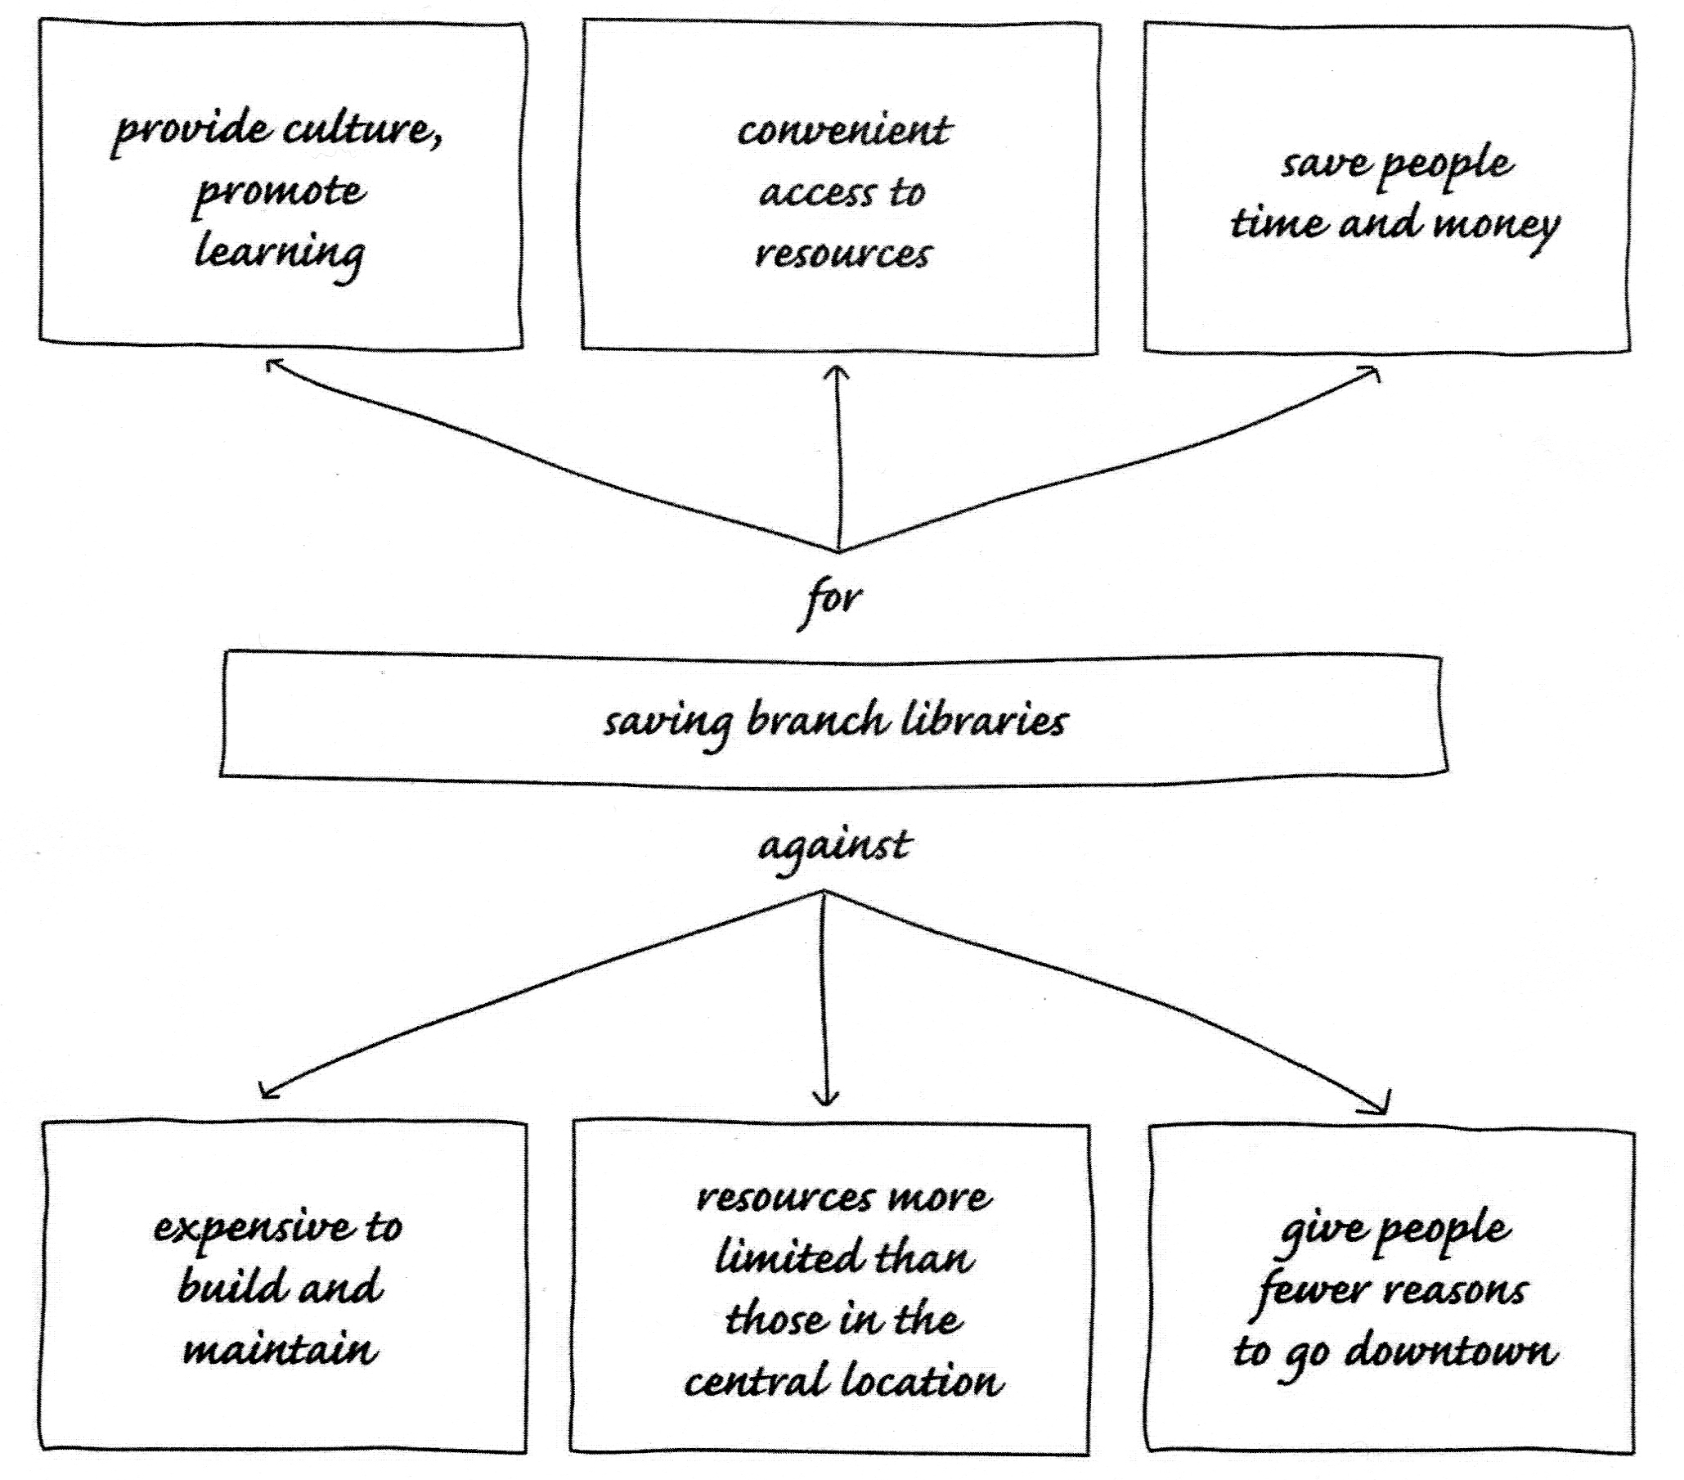

Planning: Identifying Reasons For and Against

In the center box, write the issue. In the top boxes, write reasons for supporting the issue. In the bottom boxes, write reasons against supporting the issue.

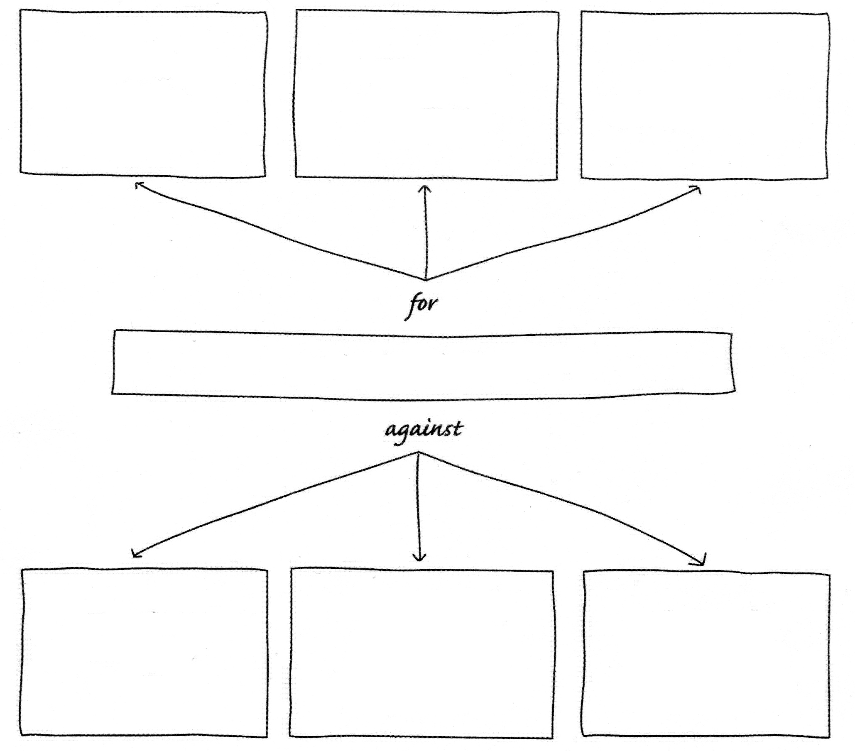

Planning: Identifying Reasons For and Against

In the center box, write the issue. In the top boxes, write reasons for supporting the issue. In the bottom boxes, write reasons against supporting the issue.

Planning: Choose Your Topic

Look at the topics you identified on page 11 and the graphic organizers on pages 13 and 14. Decide which topic you would like to write about. Pick something that you care about and that you have good reasons to support.

What is your topic?

Review a Sample Evidence Gathering Chart

The sample evidence gathering chart below is based on the argumentative essay “Save Our Branch Libraries.” A reason to be in favor of branch libraries and the support backing up that reason are shown in each box. (Support includes logical reasoning and relevant evidence, like facts, examples, data, and expert opinions.) Each box could be used to build a body paragraph in your argumentative essay.

Reason: Branch libraries are cultural centers that promote learning.
Support:

- Libraries host lectures and book clubs.
- Libraries are often the places where people learn to read.
- Branch libraries give people opportunities to learn new skills.

Source: Interview with librarian Olive Books

Reason: Branch Libraries provide resources for people all over the city.
Support:

- Branch libraries provide books, tapes, CDs, and computers.
- People without computers can find them in their neighborhoods.
- People can take useful classes.

Source: Interview with librarian Olive Books

Reason: Branch libraries save people time and money.
Support:

- The main library is 15 miles from some neighborhoods.
- Using public transportation to the library costs local people $300 a day and takes extra time.
- The libraries must serve more than 500,000 people.

Source: “Annual Report on Libraries” by Les Cash

Gathering Details

In the chart below, list two reasons, beginning with the strongest, for supporting the position you chose. Then list details that support each reason.

Reason:
Support:

Source(s):

Reason:
Support:

Source(s):

Then plan a response to a counterargument.

Reason against your position:
Your response:
Support:

Source(s):

Write your opinion statement, which is your thesis or claim, with your supporting reasons.

Your opinion statement should clearly state your opinion about the topic or problem you have chosen to write about. It should also introduce your supporting reasons. Here is the opinion statement from “Save Our Branch Libraries.”

Branch libraries are important (the writer’s opinion) because they promote culture and education, provide convenient access to information for residents in all neighborhoods, and save people time and money (introduces the supporting reasons).

Write your opinion statement in your writing notebook. Label it “opinion statement/thesis/claim.”
The parts of an Argumentative Essay

In an argumentative essay, you want to share an opinion and then show that it is correct by presenting reasons and arguments that are backed up with convincing logic and evidence. You should include at least two reasons with support to back up your opinion. You should also respond to at least one counterargument. (A counterargument is an argument or reason that goes against your opinion).

Beginning – Get the reader interested in the problem, give background information if needed, and state your opinion (thesis/claim/position) clearly.

Middle – Present the arguments/reasons and the details that support them. Address or respond to a counterargument, which is an opposing viewpoint.

Ending – Restate your opinion (thesis/claim/position) in a fresh, interesting way or remind the reader why it matters.

Transition Words and Phrases

Here are some words that you can use to connect and move between your reasons and supporting details as you write.

For agreement, addition, or similarity…

These transition words add information, reinforce ideas, and express agreement with preceding material:

in the first place
not only ... but also
as a matter of fact
in the same way
in addition
in the same way
equally important
by the same token
again
also
as well as
together with
of course
likewise
similarly
furthermore
additionally

For opposition, limitation, or contradiction…

These transition words express that there is evidence to the contrary or point out alternatives.

although this may be true
in contrast
another way of
of course..., but
on the other hand
on the contrary
at the same time
in spite of
even so/though
then again
above all
in reality
after all
but
still
unlike
and yet
while
besides
even though
although
instead
despite
conversely
otherwise
however
rather
nevertheless
regardless

For cause, condition, or purpose…

These transitional phrases present specific conditions or intentions.

in the event that
granted (that)
as/so long as
on (the) condition (that)
for the purpose of
with this intention
with this in mind
in the hope that
for fear that
in order to
seeing that
because of
due to
if ___, then ___
unless
when
whenever
while
because of
since
while
only/even if
so that
owing to

For examples, support, or emphasis…

These transitional devices are used to introduce examples as support, to indicate importance, or as an illustration so that an idea is clear to the reader.

in other words
to put it differently
for one thing
as an illustration
in this case
for this reason
to put it another way
that is to say
with attention to
by all means
an example of this is
it is important to realize
another key point
first thing to remember
most compelling evidence
must be remembered
point often overlooked
to point out
on the positive side
on the negative side
with this in mind
including
namely
chiefly
truly
certainly
surely
such as
especially
specifically
expressly
surprisingly
frequently
significantly
particularly
in fact
in general
in particular
in detail
for example
for instance
to demonstrate
to emphasize
to repeat
to clarify
to explain

For effect, consequence, or result…

Some of these transition words (thus, then, accordingly, consequently, therefore, henceforth) are time words that are used to show that after a particular time there was a consequence or an effect. Note that “for” and “because” are placed before the cause/reason. The other devices are placed before the consequences or effects.

as a result
because
because of this
in that case
for this reason
in effect
for
if ___, then ___
consequently
therefore
accordingly

For conclusion, summary, or restatement…

These transition words and phrases conclude, summarize, restate ideas, or indicate a final general statement. Also some words (like therefore) from the effect or consequence category can be used to summarize.

it can be seen that
generally speaking
in the final analysis
all things considered
as shown above
in the long run
given these points
as has been noted
in a word
for the most part
after all
in fact
in summary
in conclusion
in essence
to summarize
on balance
altogether
overall
ordinarily
usually
by and large
to sum up
on the whole
in any event
in either case
all in all
obviously
ultimately
definitely

Writing: Starting Your Essay

The first paragraph of your argumentative should: 1) grab the reader's attention, 2) introduce your issue in a way that helps your reader understand and care about it, and 3) state your opinion about it.

There are several effective ways to begin. Try one of these:

- Provide a dramatic, eye-opening statement.
- Open with an engaging story or personal experience.
- Begin with an informative quotation or dialogue.
- Ask a challenging question.
- Share important background information.
- Begin with an interesting fact or statistic.
- Start with an analogy or illustration.
- Give a detailed description.
- Relate your topic to well known current events.

Sample Beginning Paragraph:

This sample paragraph begins with a question. The opinion statement is underlined.

When you walk to school, do you ever think about the sidewalks you are using to get there? Few people ever do, unless the sidewalks are cracked and dangerous to walk on. In many of our neighborhoods, the sidewalks are breaking apart. According to the Public Works Department, about 12 miles of city sidewalks are considered dangerous and need to be repaired. Such repairs, however, are expensive. Because of city budget cuts, the sidewalks get worse and worse. Existing sidewalks need to be repaired, and new sidewalks need to be built so that people can walk the streets safely, get to school and work on time, visit local businesses, and enjoy the city's parks and museums.

Your Beginning Paragraph:

In your writing notebook, write a beginning for your argumentative essay. Label it “Argumentative Essay Beginning.” Remember to grab the reader's attention, introduce your topic, and state your opinion along with the supporting reasons that will appear in the body of the essay. (Note: Write about the topic you identified on page 15. Don’t write about sidewalks - that was just a sample.)

A good opening for your essay will draw readers in. Write a few different beginning paragraphs in your writing notebook. Label them “Alternate Beginnings.”

Next, share your writing with a classmate. After discussing your beginnings, circle the one that you will use in your essay.
Writing: Developing the Middle

The middle paragraphs of your essay should present the arguments or reasons to support your claim/thesis/position. Each paragraph should focus on one argument or reason and its supporting details. One paragraph should focus on a counterargument. You should have at least three middle paragraphs.

Sample Middle Paragraph

This middle paragraph focuses on personal safety as a reason that sidewalks should be repaired. Notice the different types of support that are used.

Personal safety is the most important reason that city sidewalks should be repaired. According to the local group Save Our Sidewalks (SOS), last year 73 people suffered injuries related to sidewalks. Half of those injuries resulted from accidents caused by sidewalks that had been improperly cleared of snow and ice. The other injuries were caused by uneven, unstable, or missing pavement. One victim, Jennifer O'Neil, was walking her dog when she tripped on a broken section of sidewalk. She was hospitalized with a broken ankle. Mrs. O'Neil said that she knew the sidewalk wasn't stable, but she was afraid to walk her dog in a busy street. "I didn't want to get hit by a bicycle or a car." People should not have to make such choices.

In your writing notebook, write the middle paragraphs (at least three) for your argumentative essay. Label them “Argumentative Essay Middle.” Remember to focus on a different reason for each paragraph. Then add details to support each reason. (You identified your reasons and support on pages 17 and 18.)

Writing: Writing a Strong Ending

The ending of your argumentative essay should restate or reinforce your position or remind the reader why it matters. The tricky part is to restate your position in a clever, interesting way. Don’t just repeat yourself. Nobody likes it when you repeat yourself. Don’t just keep saying the same thing. Nobody likes it when you repeat yourself.

Sample Ending Paragraph

The sidewalks are just as important to people, businesses, and the quality of life in this city as the roads are. Yet 10 times more funding is available for repairing roads than for repairing sidewalks. As a result, many people must walk in dangerously busy streets in order to get to work or to stores. Poorly maintained sidewalks result in many people being injured every year. That means that people should raise the sidewalk issue at city council meetings and join groups like Save Our Sidewalks. After all, without safe sidewalks, city life can be both difficult and dangerous.

In your writing notebook, write the ending paragraph of your argumentative essay. Label it “Argumentative Essay Ending.” Be sure to restate or reinforce your position and remind the reader why it matters.

Writing: Forming a Complete First Draft

Take the beginning, middle, and end of your essay from your writing notebook and put them together to form your argumentative essay. Type them using Google Docs. If you can’t get to a computer, you can write your essay by hand, but it must be neat and easy to read.

- The heading goes in the upper left corner of your essay. Put your name, hour, date, and teacher’s name in the heading, like this:

Bart Simpson

Mr. Duyck

1st Hour LA 8

24 May, 2019

- Include your last name with the page number in the upper right corner.

- Center your title.

- Use the default page margins.

- Double space your text.

- Indent your paragraphs.

- Use a simple, classic font like Times New Roman.

- Use 12 point text.

- All text should be justified left except the title and the page numbers.

- Name your file like this so we can find it later:

Lastname Firstname Hour Title

Simpson Bart 1st Hour Monkey Hats Matter

- Keep track of your file to your Google Drive.
Revising: Avoiding False Arguments

Your argumentative essay needs reasoning that is strong and logical.

Read the explanations and examples of false arguments below, then rewrite the arguments so that the reasoning is more logical.

Slippery Slope: This is a conclusion based on the premise that if A happens, then eventually, through a series of small steps, Z will happen too, basically equating A and Z. So, if we don't want Z to occur, A must not be allowed to occur either.

Example: If we ban large SUVs because they are bad for the environment, eventually the government will ban all cars.

In this example, the author is equating banning SUVs with banning all cars, which is not the same thing.

More logical: If we ban large SUVs, it will be hard on people with large families who live in areas that get lots of snow.

Circular Argument: This restates the argument rather than actually proving it.

Example: President Obama is a good communicator because he speaks effectively.

In this example, the conclusion that Obama is a "good communicator" and the evidence used to prove it, "he speaks effectively," are basically the same idea.

More logical:

Either/or: This is a conclusion that oversimplifies the argument by reducing it to only two sides or choices.

Example: We can either stop using cars or we can destroy the earth.

In this example, the two choices are presented as the only options, yet the author ignores a range of choices in between such as developing cleaner technology, car-sharing systems for necessities and emergencies, or better community planning to discourage daily driving.

More logical:

Next: Check your argumentative essay and fix any false arguments or illogical thinking that you find, or trade papers with a classmate and check each other's thinking.

Revising: Peer Responding

Have a classmate read your argumentative essay and complete the response sheet below. (Then do the same for them.) Be sure to look carefully to see if all three parts are doing what they are supposed to do. The beginning should get the reader’s attention and introduce the problem. The middle paragraphs should each present one reason and support that reason. The end should remind the reader why this matters.

Author: Responder:

Title:

I like:

I would change:

Strong ideas, words, and phrases:

Revising: Using a Checklist

Use the following checklist to help you review and revise your first draft. Make changes in your draft as needed so that your argumentative essay contains a strong opinion statement, clearly supported reasons, and a strong ending.

Revising Checklist

Yes No Does the first paragraph give background info or a reason to care about the problem?

Yes No Does the first paragraph clearly state the thesis/claim/opinion?

Yes No Does the second paragraph offer a clear reason/argument with support?

Yes No Does the third paragraph offer a clear reason/argument with support?

Yes No Does the fourth paragraph offer a response to a counterargument with support?

Yes No Does the last paragraph restate your argument or remind the reader why
this matters?

Yes No Is the essay neat and easy to read? (Complete sentences with capital letters and end punctuation, complete paragraphs, proper formatting, correct spelling, etc.)

Adding a Title

You need to write a title for your argumentative essay. The title should hook your reader and reflect your opinion. Here are some guidelines to follow:

• Reflect your theme.
What is the theme of your essay?

• Use strong, colorful words.
We're a School, Not an Airport, not Rolling Backpacks Are a Real Problem

• Give the words rhythm.
Avoid Rush Hour at Harrison High, not Crowded Hallways Are a Problem

• Be imaginative.
Is Security in the Eye of the Beholder? not Security Cameras in Our School

In your writing notebook, write a few possible titles using these ideas. Circle the best one.

Revising: Revise Your Essay

Reflect on the ideas in pages 25 to 28 and use them to make your argumentative essay better.

Focus on ideas that need to be changed. Add, cut, reorder, and rewrite different parts as needed.

Pay special attention to peer responses. Your peers are your audience, and your goal is to convince them to agree with you.

Save your first draft so that you have a record of the changes you have made.

Reflecting On Your Writing

Complete these statements in your writing notebook:

- The thing I like best about my essay is…

- The part I would like to change is…

- As a writer, I should work on…

- While completing my essay, the main thing I learned about writing is…
Name ___________________________________________________ Hour ________

How I Improved My Argumentative Essay

Complete this page, remove it from this packet, and turn it in with your essay.

What changes did you make when you revised your essay? Be specific.

For the most important change that you made, copy the passage before and after the change.

Before:

After:

