“Low Battery” Paints a Poignant Picture of How Glued We Are to Our Devices 26. Jun. 2018

As we get smarter mobile phones, faster Internet speeds, and more people to communicate with across the globe, we can’t help but exclaim, “What a time to be alive!” But, for every exciting promise of an even better future comes the gloomy reality we face today. We live in a time where everyone can easily connect with anyone, anywhere, and anytime, yet we are lonelier than ever. Spanish photographer Oscar Penelo translates this reality in an intimate portrait project titled Low Battery.
Created as a reflection of today’s obsession with being connected through various devices, the project depicts scenarios we all constantly find ourselves in: tapping away at our smartphones, being physically present with friends and loved ones yet glued to our screens, always waiting for the next notification or message. Faces lit up by the glow of smartphones, tablets, and laptops have become common sights. It’s both an observation by Oscar and an invitation for us to examine whether our connections are genuine or just a fleeting product of technology.
“Low Battery begins with a distant observation of the environment, of daily life into the intimate life,” Barcelona-based Oscar says in his artist statement. “With this series of photographs, the author wants us to observe our surroundings, to stop and live without screens that illuminate us.”
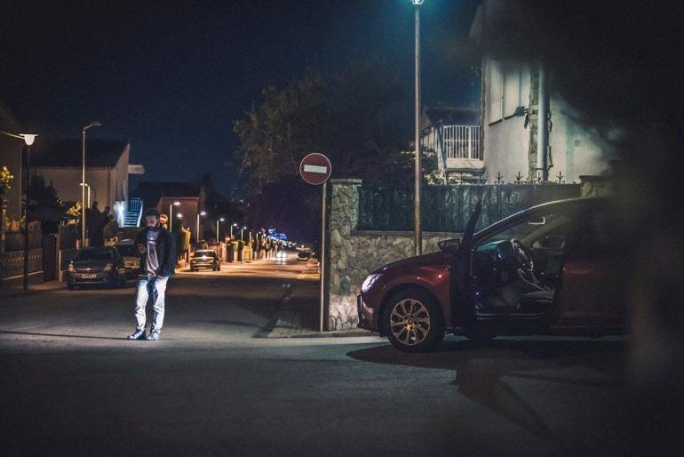
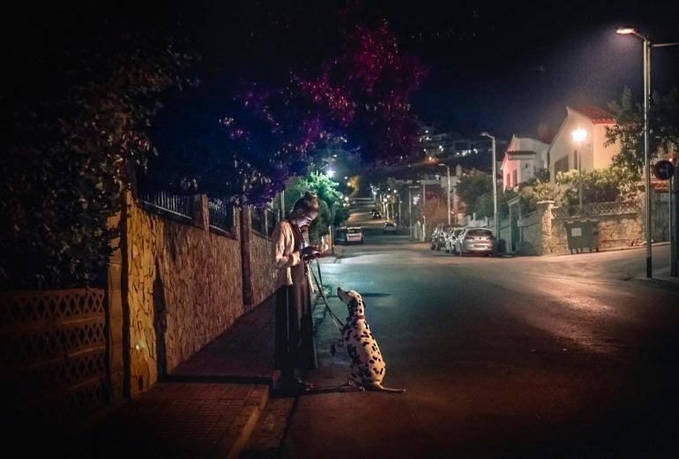
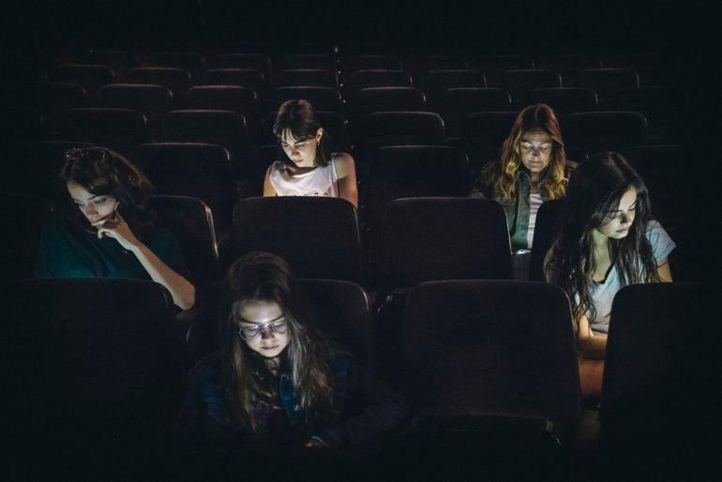
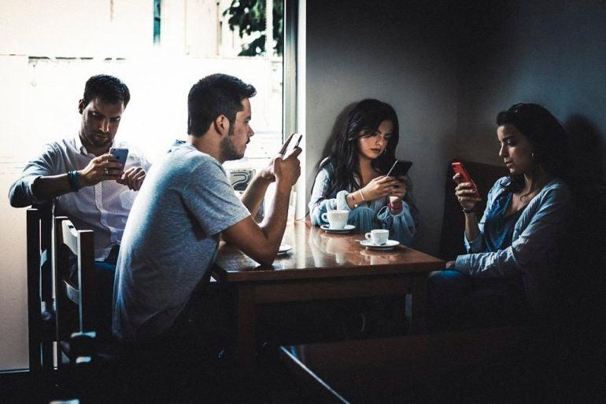

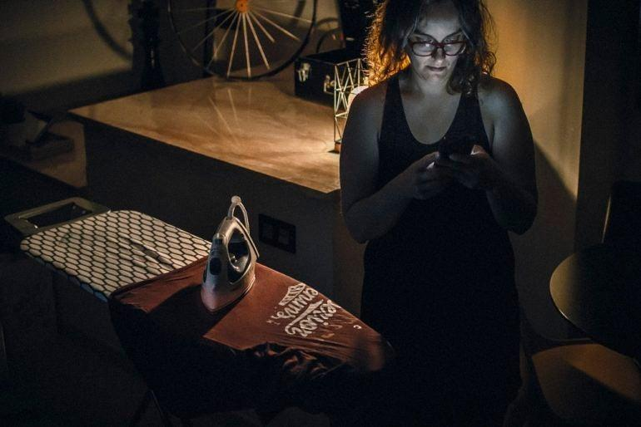
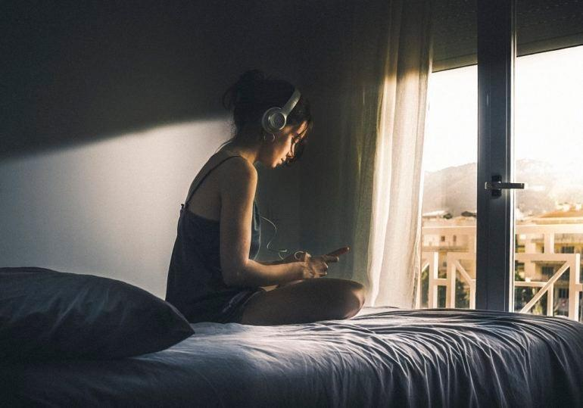
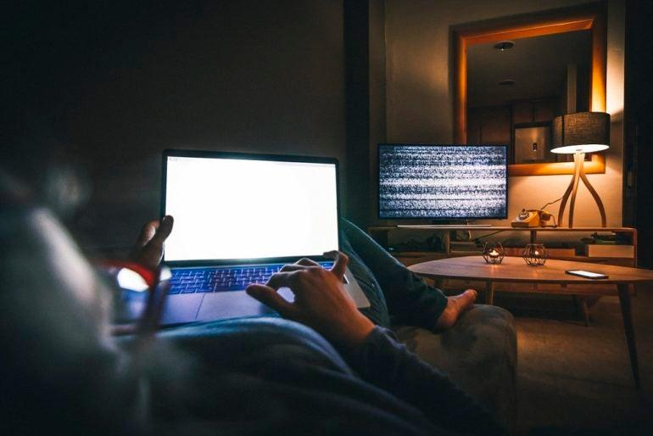

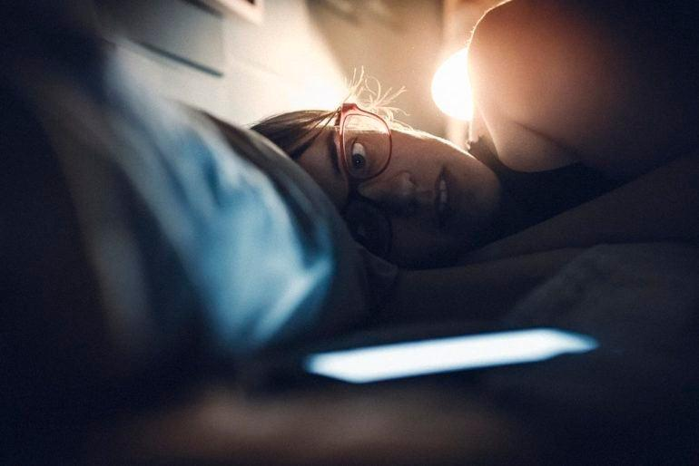
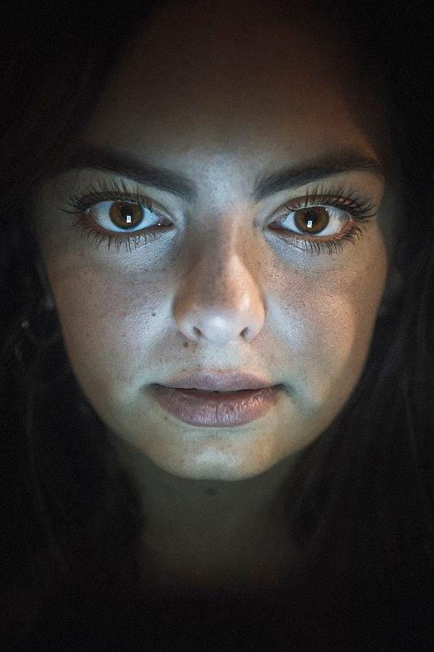
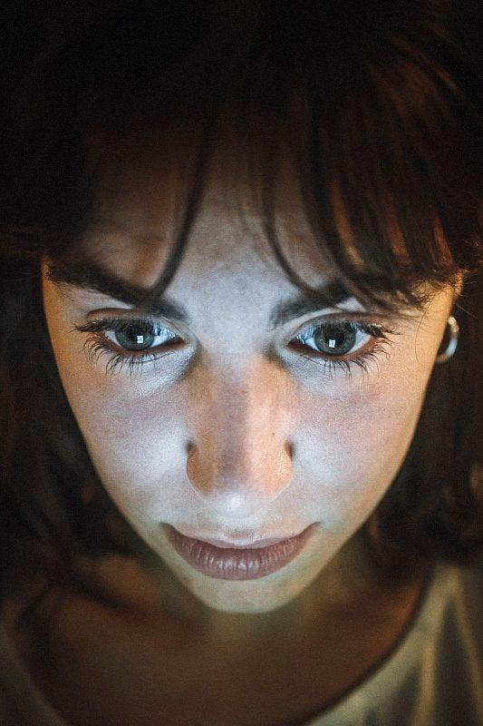
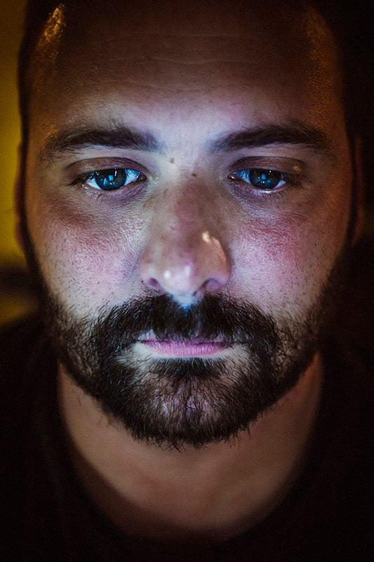
Oscar’s work stands out because it covers both the big picture and the deeper story behind his chosen topic. His subjects are represented in everyday scenarios that paint a picture of how we act as individuals in our solitude, and behave as part of the “connected” society. It’s also so contemporary and relatable that it almost hurts; as a viewer, it’s easy to see yourself in the frame, your face lit up by the screen as you speak to someone miles away, type an e-mail to old friend you hope to reconnect with, or even wait for a notification that will never come.

